3. Budget Maintenance: 2. Post Final Budget

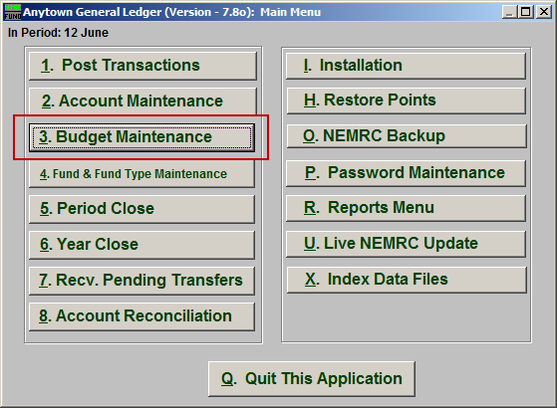
Click on “3. Budget Maintenance” from the Main Menu and the following window will appear:

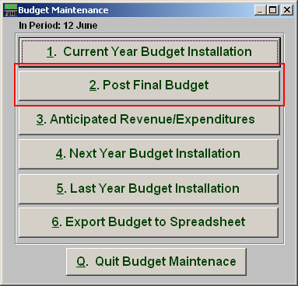
Click on “2. Post Final Budget” from the Budget Maintenance Menu and the following window will appear:

Post Final Budget

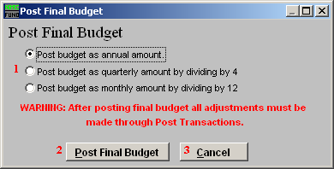
- Post budget as…: Select the option which fits your budgeting and reporting policies.

- Post Final Budget: Click this button to record budgetary transactions in the system. Any budget adjustments must be performed by posting budget transactions from “1. Post Transactions” on the Main Menu.

- Cancel: Click “Cancel” to cancel and return to the previous screen.

